# Table of Contents

(see left of screen for navigable table of contents)

Color Palette (2)

Typography (3-4)

Logo (5)

Components

Landing Page

# Color Palette

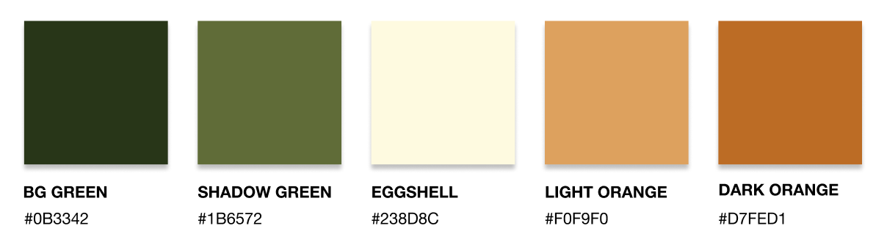

## Code

/* Dark Green */

background: #606C38;

/* Shadow Green */

background: #283618;

/* Eggshell 3 */

background: #BC6C25;

/* Light Orange */

background: #DDA15E;

/* Dark Orange */

background: #FEFAE0;

# Typography

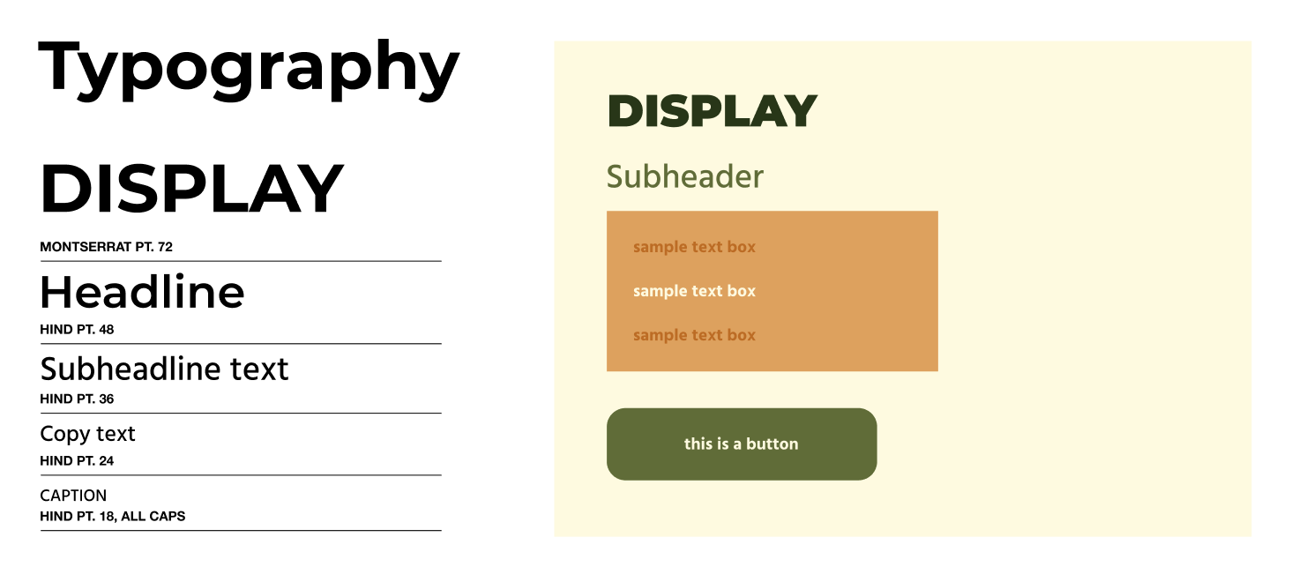

/* DISPLAY */

font-family: Montserrat;

font-style: normal;

font-weight: bold;

font-size: 72px;

line-height: 88px;

color: #000000;

/* Headline */

font-family: Montserrat;

font-style: normal;

font-weight: 600;

font-size: 48px;

line-height: 59px;

color: #00000

/* Subheadline text */

font-family: Hind;

font-style: normal;

font-weight: 500;

font-size: 36px;

line-height: 58px;

/* identical to box height */

color: #000000;

/* Copy text */

font-family: Hind;

font-style: normal;

font-weight: 500;

font-size: 24px;

line-height: 38px;

color: #000000;

/* CAPTION */

font-family: Hind;

font-style: normal;

font-weight: 500;

font-size: 18px;

line-height: 29px;

color: #000000;

# Logo



/* LORELAD MAIN LOGO */

font-family: MuseoModerno;

font-style: normal;

font-weight: 900;

font-size: 72px;

line-height: 114px;

text-align: center;

color: #606C38;



/* LORELAD b&w */

font-family: MuseoModerno;

font-style: normal;

font-weight: 900;

font-size: 72px;

line-height: 114px;

text-align: center;

color: #000000;



/* Rectangle 9 */

position: absolute;

width: 396px;

height: 117px;

left: 195px;

top: 1591px;

background: #606C38;

/* LORELAD */

position: absolute;

width: 460px;

height: 117px;

left: 163px;

top: 1591px;

font-family: MuseoModerno;

font-style: normal;

font-weight: 900;

font-size: 72px;

line-height: 114px;

text-align: center;

color: #FEFAE0;

# Components

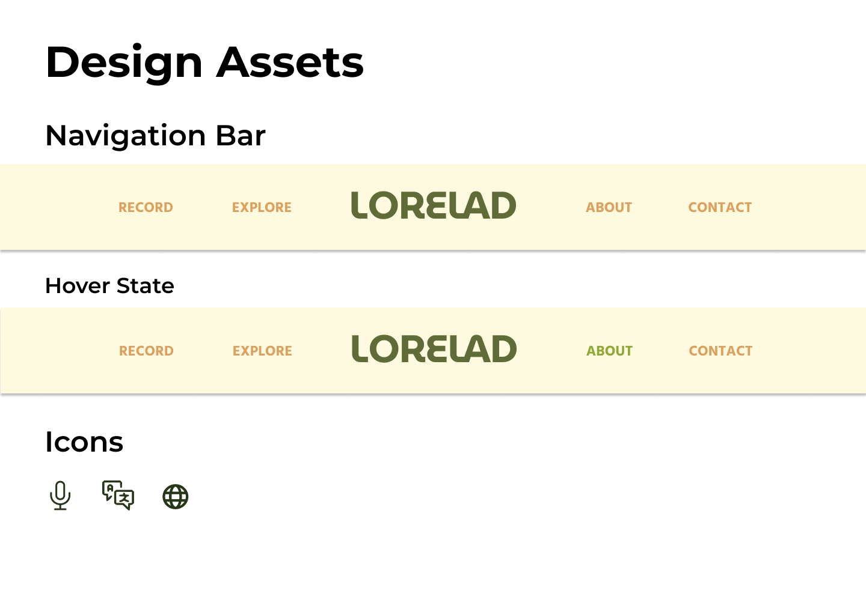

Navigation Bar

/* Rectangle 1 */

position: absolute;

left: 0%;

right: 0%;

top: 0%;

bottom: 0%;

background: #FEFAE0;

box-shadow: 0px 4px 4px rgba(0, 0, 0, 0.25);

/* Lorelad */

position: absolute;

left: 33.4%;

right: 33.33%;

top: 12.59%;

bottom: 13.29%;

font-family: MuseoModerno;

font-style: normal;

font-weight: bold;

font-size: 64px;

line-height: 102px;

text-align: center;

text-transform: uppercase;

color: #606C38;

/* record */

position: absolute;

left: 10.62%;

right: 76.94%;

top: 38.46%;

bottom: 36.36%;

font-family: Hind;

font-style: normal;

font-weight: bold;

font-size: 24px;

line-height: 38px;

text-align: center;

text-transform: uppercase;

color: #DDA15E;

/* about */

position: absolute;

left: 64.1%;

right: 23.47%;

top: 38.46%;

bottom: 36.36%;

font-family: Hind;

font-style: normal;

font-weight: bold;

font-size: 24px;

line-height: 38px;

text-align: center;

text-transform: uppercase;

color: #DDA15E;

/* explore */

position: absolute;

left: 24.03%;

right: 63.54%;

top: 38.46%;

bottom: 36.36%;

font-family: Hind;

font-style: normal;

font-weight: bold;

font-size: 24px;

line-height: 38px;

text-align: center;

text-transform: uppercase;

color: #DDA15E;

/* contact */

position: absolute;

left: 76.94%;

right: 10.62%;

top: 38.46%;

bottom: 36.36%;

font-family: Hind;

font-style: normal;

font-weight: bold;

font-size: 24px;

line-height: 38px;

text-align: center;

text-transform: uppercase;

color: #DDA15

Navigation Bar (Hover State)

/change color of text field to [ color: #8EA934; ]

Ex: /* about */

font-family: Hind;

font-style: normal;

font-weight: bold;

font-size: 24px;

line-height: 38px;

text-align: center;

text-transform: uppercase;

color: #8EA934;

Icons

Record

/* Vector */

position: absolute;

left: 37.5%;

right: 37.5%;

top: 4.17%;

bottom: 37.5%;

border: 3px solid #283618;

/* Vector */

position: absolute;

left: 20.83%;

right: 20.83%;

top: 41.67%;

bottom: 20.83%;

border: 3px solid #283618;

/* Vector */

position: absolute;

left: 50%;

right: 50%;

top: 79.17%;

bottom: 4.17%;

border: 3px solid #283618;

/* Vector */

position: absolute;

left: 33.33%;

right: 33.33%;

top: 95.83%;

bottom: 4.17%;

border: 3px solid #283618;

Translate